Chapter 6 Windows Programming Exercises

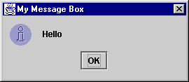
- Write a Java Program, which Displays a message box saying “Hello”.

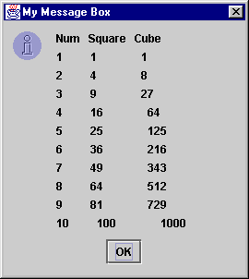
- Write a Java Program which Displays a message box showing the following table;
Num | Square | Cube
1 | 1 | 1
2 | 4 | 8
… | … | …
10 | 100 | 1000

- Write a Java Program, which displays a dialog box asking for your first name, the program should then display a dialog to ask you for your surname. Finally display a message box displaying your full name.
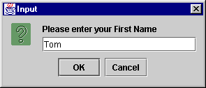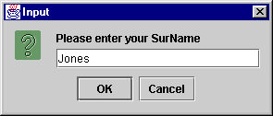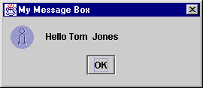
- Write a Java Program, which displays a dialog asking for an integer, the program should then display a message box, which says if he number is even or odd.
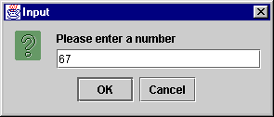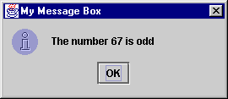

- Write a Calculator in Java. The program should ask for a number, then ask for one of the following operators
- sqr [squared, 4 square is 16]
- inv [inverse, e.g the inverse of 4 is ¼ or 0.25]
- cube [cubed, e.g. the cube of 3 is 27]
The program should then display the result in a message box. Display an error message if an unknown operator is entered.
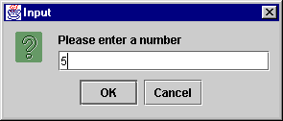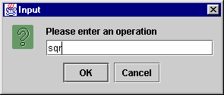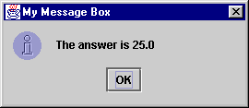
- Extend the calculator from part one. Allow the user to enter a binary operator (+,-,* or /), if a binary operator is entered then ask for another number. The program should then display the result in a message box.
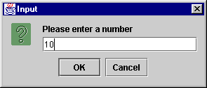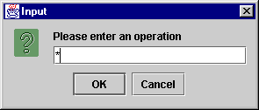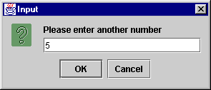
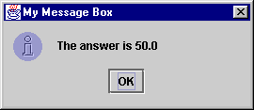
- Finally allow the user to enter the operator, times, which causes the calculator to print out the 10 times table for the number.
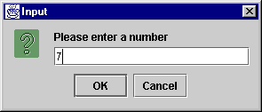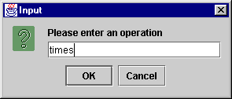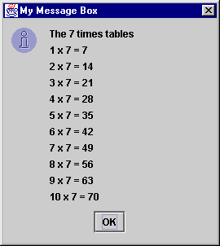
- Write a Java application that implements a fully functional calculator (see Windows calculator for functionality). The program must allow the user to enter numbers and perform, addition, subtraction, multiplication and division etc. Initially the user may enter two operands and perform a calculation. The user should be able to use the result of initial calculations as operands in further calculations and so on. The program must implement the numeric keypad.
- Write a Java application that implements a currency converter. The program must allow the user to convert between currencies, for example between Euros and Dollars, between dollars and sterling etc. The user should be able to use the result of an initial conversion as input to further conversions and so on. Include at least four major currencies.
- Write a Java application that creates a multi conversion tool. The program must allow the user to choose the type of conversion that they require, perform the conversion and output the result of the conversion. The user should then be able to perform another conversion. The multi conversion tool will allow the user to convert from inches to feet (12 inches equals 1 foot), from pounds to Euro (1 Euro equals 0.79 pounds), or from Celsius to Fahrenheit (celsius = ⁵/₉ (fahr – 32) or fahr = (celsius * ⁹/₅) + 32)).
- Create a single program that integrates the functionality of exercises 8 to 10.
- Add menus to each of the above programs (8-11) that will allow the user to access all functionality of the programs via the menus.
- Create a simple document editor. The editor should function in a similar fashion to Notepad. Initially you will only be able to add text and delete text in your editor window, but eventually you will be able to save your documents to the hard drive.
- There are several classes available on the server for reading and writing to files, you will need to use these in your editor.

